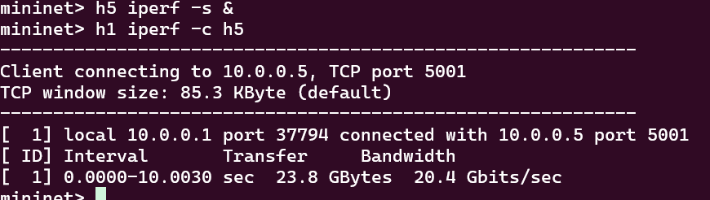

P1_learning

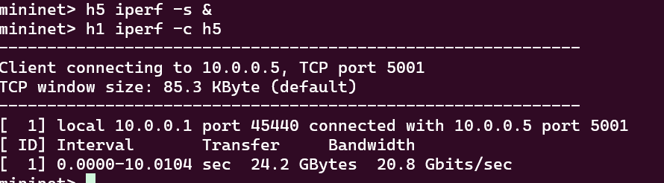

P1_hub

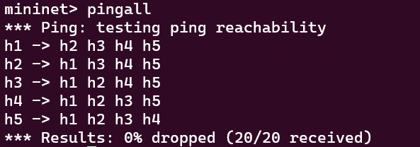

Pingall

P1_hub

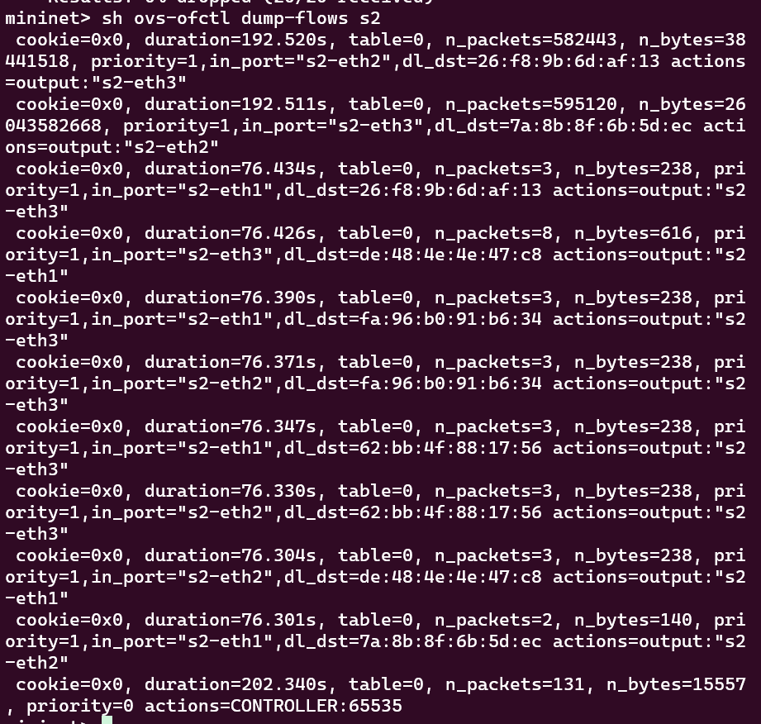

P1_learning

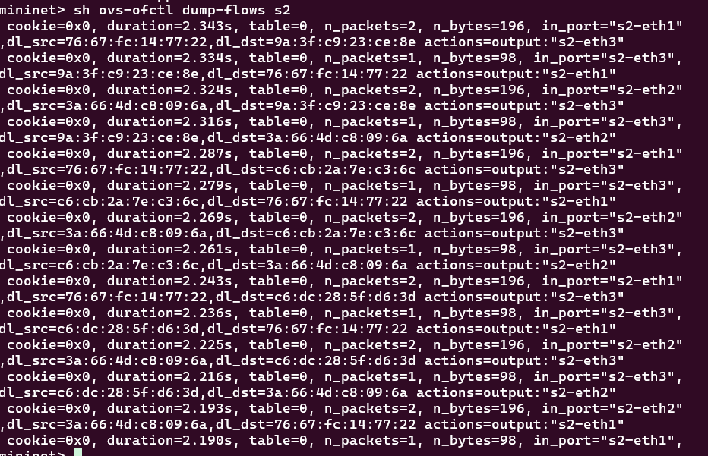

Running mininet on separate terminal-

Sudo python3 p1_topo.py

Clean mininet using sudo mn -c

On vs code terminal in py_3.9.6 env run ryu_manager p1_learning.py